References
{Potential} What is Mininet (DONE) (viewed 1st May 21): http://mininet.org/overview/
What is ODL (DONE) (viewed 6th Apr 21): https://www.sdxcentral.com/networking/sdn/definitions/opendaylight-controller/
{Potential} How to download ODL (DONE) (viewed 15th May 2021): https://www.oreilly.com/library/view/learning-opendaylight/9781782174523/da331b20-3bac-492d-8cdd-c1f69757b23b.xhtml
How to download ODL (DONE) (viewed 15th May 2021): https://john.soban.ski/how-to-install-opendaylight-on-centos-or-ubuntu.html
(DO NOT USE IN REPORT) What is DASH (NOT DONE) (viewed 15th May 2021): https://en.wikipedia.org/wiki/Dynamic_Adaptive_Streaming_over_HTTP
Dash’s GitHub wiki (NOT DONE) (viewed 15th May 2021): https://github.com/Dash-Industry-Forum/dash.js/wiki
What is MobaXterm (DONE) (viewed 15th May 2021): https://mobaxterm.mobatek.net/
Mininet’s official documentation walkthrough (commands and explanations) (DONE) (viewed 16th May 2021): http://mininet.org/walkthrough/
Automating a controller start-up for Mininet (DONE) (viewed 16th May 2021): http://mininet.org/blog/2013/06/03/automating-controller-startup/
SDN Based Architecture to Improve Video Streaming in Home Networks (NOT DONE) (viewed 18th May 2021): https://ieeexplore.ieee.org/document/7474092
https://ieeexplore.ieee.org/stamp/stamp.jsp?tp=&arnumber=7474092
https://hal.sorbonne-universite.fr/hal-01365329/document
Two articles on DLE: https://dle.plymouth.ac.uk/course/view.php?id=47609
SDN-based throughput allocation in wireless networks for heterogeneous adaptive video streaming applications (NOT DONE) (viewed 18th May 2021): https://ieeexplore.ieee.org/abstract/document/7986416
What is a network controller (DONE) (viewed 18th May 2021): https://www.cisco.com/c/en/us/solutions/enterprise-networks/what-is-a-network-controller.html

References Duplicate
{Potential} What is Mininet (DONE) (viewed 1st May 21): http://mininet.org/overview/
What is ODL (DONE) (viewed 6th Apr 21): https://www.sdxcentral.com/networking/sdn/definitions/opendaylight-controller/
{Potential} How to download ODL (DONE) (viewed 15th May 2021): https://www.oreilly.com/library/view/learning-opendaylight/9781782174523/da331b20-3bac-492d-8cdd-c1f69757b23b.xhtml
How to download ODL (DONE) (viewed 15th May 2021): https://john.soban.ski/how-to-install-opendaylight-on-centos-or-ubuntu.html
(DO NOT USE IN REPORT) What is DASH (NOT DONE) (viewed 15th May 2021): https://en.wikipedia.org/wiki/Dynamic_Adaptive_Streaming_over_HTTP
Dash’s GitHub wiki (NOT DONE) (viewed 15th May 2021): https://github.com/Dash-Industry-Forum/dash.js/wiki
What is MobaXterm (DONE) (viewed 15th May 2021): https://mobaxterm.mobatek.net/
Mininet’s official documentation walkthrough (commands and explanations) (DONE) (viewed 16th May 2021): http://mininet.org/walkthrough/
Automating a controller start-up for Mininet (DONE) (viewed 16th May 2021): http://mininet.org/blog/2013/06/03/automating-controller-startup/
SDN Based Architecture to Improve Video Streaming in Home Networks (NOT DONE) (viewed 18th May 2021): https://ieeexplore.ieee.org/document/7474092
https://ieeexplore.ieee.org/stamp/stamp.jsp?tp=&arnumber=7474092
https://hal.sorbonne-universite.fr/hal-01365329/document
Two articles on DLE: https://dle.plymouth.ac.uk/course/view.php?id=47609
SDN-based throughput allocation in wireless networks for heterogeneous adaptive video streaming applications (NOT DONE) (viewed 18th May 2021): https://ieeexplore.ieee.org/abstract/document/7986416
What is a network controller (DONE) (viewed 18th May 2021): https://www.cisco.com/c/en/us/solutions/enterprise-networks/what-is-a-network-controller.html

Harvard references (before alphabet)
Mininet. (2021). Mininet Overview. Mininet. Viewed 1st May 2021. <http://mininet.org/overview/>
Moriarty-Siler, E. (2014). What Is an OpenDaylight Controller? AKA: OpenDaylight Platform. SDX Central. Viewed 6th Apr 2021. <https://www.sdxcentral.com/networking/sdn/definitions/opendaylight-controller/>
Sobanski, J. (2018). How to install OpenDaylight on CentOS 7 or Ubuntu 16.04 LTS. John Sobanski. Viewed 15th May 2021. <https://john.soban.ski/how-to-install-opendaylight-on-centos-or-ubuntu.html>
Dsilhavy. (2021). Dash-Industry-Forum. GitHub. Viewed 15th May 2021. <https://github.com/Dash-Industry-Forum/dash.js/wiki>
MobaXterm. (2021). MobaXterm. MobaXterm Mobatek. Viewed 15th May 2021. <https://mobaxterm.mobatek.net/>
Mininet. (2021). Mininet Walkthrough. Mininet. Viewed 16th May 2021. <http://mininet.org/walkthrough/>
Mininet. (2021). Automating Controller Startup. Mininet. Viewed 16th May 2021. <http://mininet.org/blog/2013/06/03/automating-controller-startup/>
Abuteir, R. Fladenmuller, A. Fourmaux, O. (2016). SDN Based Architecture to Improve Video Streaming in Home Networks. IEEE: New York.
Taha, M. Garcia, L. Jimenez, J. Lloret, J. (2017). SDN-based throughput allocation in wireless networks for heterogeneous adaptive video streaming applications. IEEE: New York.
Cisco. (2021). What Is a Network Controller?. Cisco Systems. Viewed 18th May 2021. <https://www.cisco.com/c/en/us/solutions/enterprise-networks/what-is-a-network-controller.html>
Al-Issa, A. Bentaleb, A. Barakabitze, A. Zinner, T. Ghita, B. (2019). Bandwidth Prediction Schemes for Defining Bitrate Levels in SDN-enabled Adaptive Streaming. IEEE: New York
Al-Issa, A. Bentaleb, A. Barakabitze, A. Zinner, T. Ghita, B. (2019). BBGDASH: A Max-Min Bounded Bitrate Guidance for SDN Enabled Adaptive Video Streaming. IEEE: New York.

Harvard references (after alphabet)
A. Barakabitze,A. Barakabitze,A. Bentaleb,A. Bentaleb,A. Fourmaux,A. Zinner,A. Zinner,B. (2019). BBGDASH: A Max-Min Bounded Bitrate Guidance for SDN Enabled Adaptive Video Streaming. IEEE: New York.,B. (2019). Bandwidth Prediction Schemes for Defining Bitrate Levels in SDN-enabled Adaptive Streaming. IEEE: New York
Al-Issa,E. (2014). What Is an OpenDaylight Controller? AKA: OpenDaylight Platform. SDX Central. Viewed 6th Apr 2021. <https://www.sdxcentral.com/networking/sdn/definitions/opendaylight-controller/>
Sobanski,J. (2017). SDN-based throughput allocation in wireless networks for heterogeneous adaptive video streaming applications. IEEE: New York.
Cisco. (2021). What Is a Network Controller?. Cisco Systems. Viewed 18th May 2021. <https://www.cisco.com/c/en/us/solutions/enterprise-networks/what-is-a-network-controller.html>
Al-Issa,J. (2018). How to install OpenDaylight on CentOS 7 or Ubuntu 16.04 LTS. John Sobanski. Viewed 15th May 2021. <https://john.soban.ski/how-to-install-opendaylight-on-centos-or-ubuntu.html>
Dsilhavy. (2021). Dash-Industry-Forum. GitHub. Viewed 15th May 2021. <https://github.com/Dash-Industry-Forum/dash.js/wiki>
MobaXterm. (2021). MobaXterm. MobaXterm Mobatek. Viewed 15th May 2021. <https://mobaxterm.mobatek.net/>
Mininet. (2021). Mininet Walkthrough. Mininet. Viewed 16th May 2021. <http://mininet.org/walkthrough/>
Mininet. (2021). Automating Controller Startup. Mininet. Viewed 16th May 2021. <http://mininet.org/blog/2013/06/03/automating-controller-startup/>
Abuteir,J. Lloret,L. Jimenez,M. Garcia,Mininet. (2021). Mininet Overview. Mininet. Viewed 1st May 2021. <http://mininet.org/overview/>
Moriarty-Siler,O. (2016). SDN Based Architecture to Improve Video Streaming in Home Networks. IEEE: New York.
Taha,R. Fladenmuller,T. Ghita,T. Ghita

Notes
REFER TO TEAMS CHANNEL FOR SOME USEFUL INFO
Xterm is already installed on a Mininet VM, but not normal ubuntu machine. Use command ‘sudo apt install xterm’ to install it.
https://stackoverflow.com/questions/50856080/0-connecting-to-in-archive-ubuntu-com-takes-too-long-time
sudo nano /etc/gai.conf
precedence ::ffff:0:0/96 100

Firstly, a new Linux virtual machine is created, which uses the “Mininet VM installation” file provided through Mininet’s official website.

Start Process
- Set mininet IP address to 206 (because it changed to 209)
- Start ODL
- Log into Mininet with Moba Xterm
- Start Xterm

To set IP address
sudo ifconfig ens33 192.168.10.206 netmask 255.255.255.0

Mininet details (Ubuntu Server 18.04.5)
VM name: Mininet VM (ubuntu 18)
Username: mininet
Password: mininet
IP address: 192.168.10.206
IP address: 192.168.10.235

ODL (controller details)
VM name: ODL VM
Username: odl
Password: odl
IP address: 192.168.10.239

Username: admin
Password: admin

Everything to download
sudo apt-get install apache2
sudo apt-get install unzip
sudo apt-get install x264
sudo apt-get install gpac
(sudo apt update)
sudo apt-get install ffmpeg
sudo apt-get install mininet
sudo apt-get install xterm
sudo apt-get install x264
sudo apt-get install gpac
sudo apt-get install ffmpeg
sudo apt install firefox

Dash
Prepare video

New mininet server
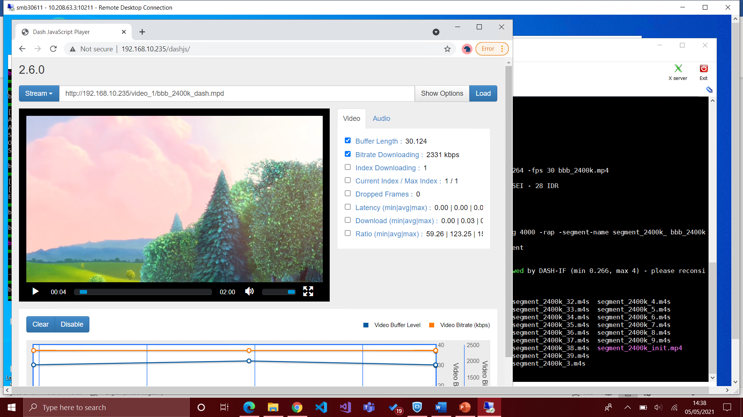

Just finished redoing video on ubuntu 18 v2 (has ip address 235). Might change ip address, might not.

Getting topology streaming working
Stop apache from root before starting mn -x… otherwise apache doesn’t work in topology
$ sudo service apache2 stop
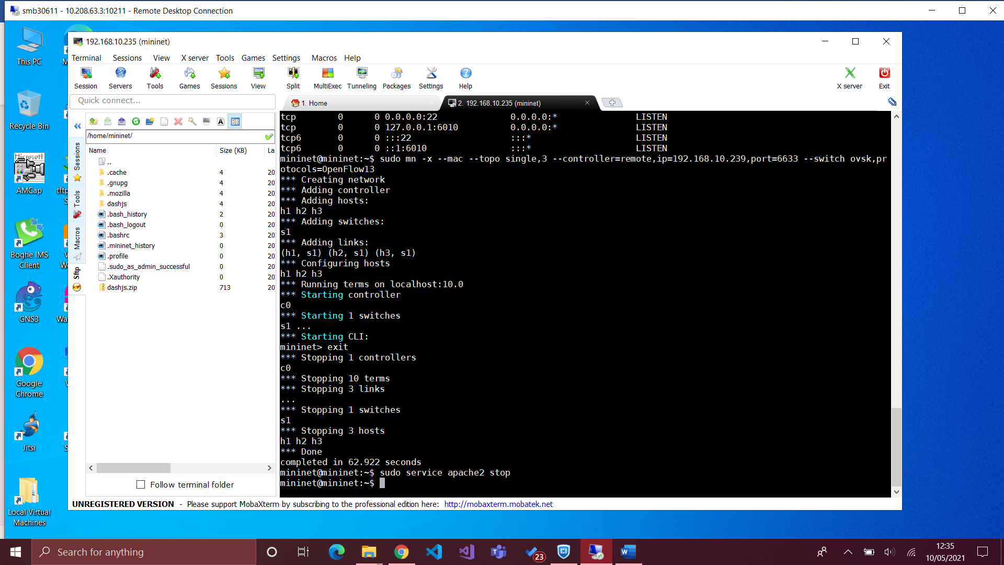
Start apache on h1
$ apache2ctl -k start
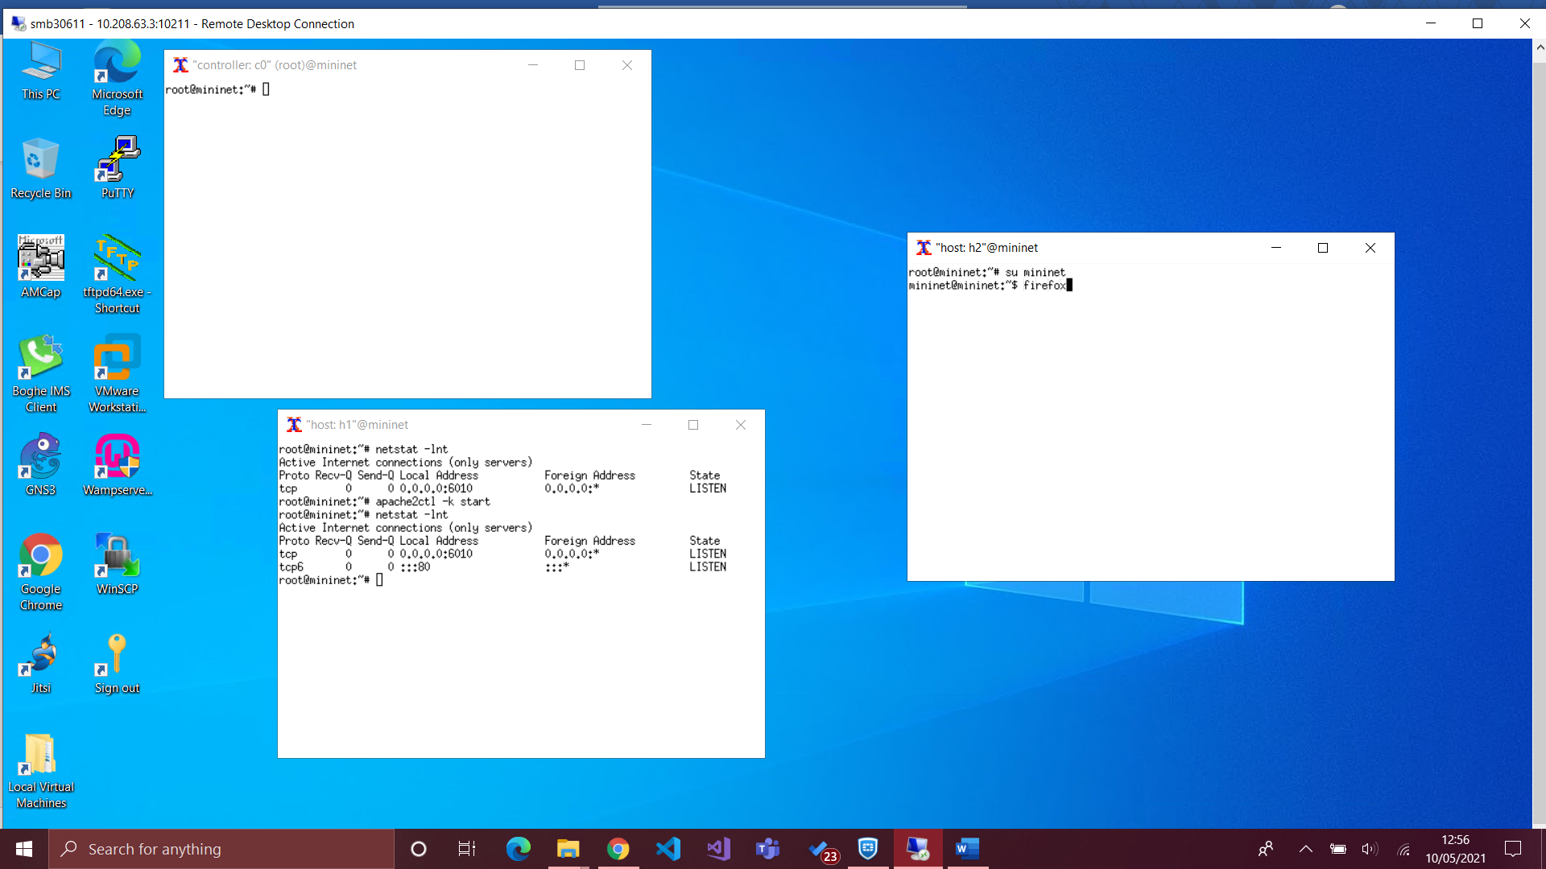
To check port 80
$ netstat -lnt
To check apache2 running
$ ps -aux | grep apache2

Streaming different videos
10.0.0.1/dashjs
http://10.0.0.1/video_1/bbb_2400k_dash.mpd
http://10.0.0.1/video_2/bbb_1200k_dash.mpd
http://10.0.0.1/video_3/bbb_600k_dash.mpd
$ sudo mn -x --mac --topo single,3 --controller=remote,ip=192.168.10.239,port=6633 --switch ovsk,protocols=OpenFlow13
$ sudo mn -x --mac --topo single,3 --controller=remote,ip=192.168.10.239,port=6633 --switch ovsk,protocols=OpenFlow13 --link tc,bw=50,delay=10ms
$ sudo mn -x --mac --topo single,3 --controller=remote,ip=192.168.10.239,port=6633 --switch ovsk,protocols=OpenFlow13 --link tc,bw=10,delay=30ms

Comments to be stated in report
A test was to be conducted with a slower bandwidth; however, it did not load the dash player in the first place.
Test 3 was playable but was VERY choppy and slow
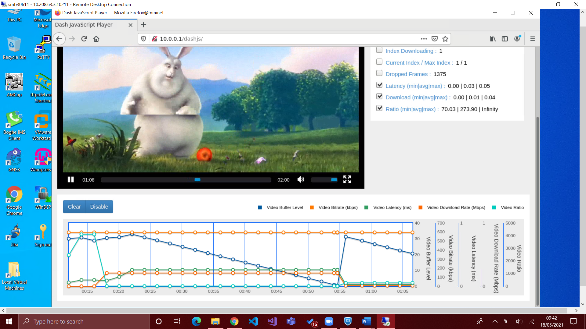
Inconsistent with medium/slower bandwidth (fluctuation in statistical values after the 50 second mark).
Topology can be created with a python script; see appendix lorem for a detailed script for default network conditions.
Recordings:
- Buffer level
- Bitrate
- Latency
- Download rate
- Ratio

